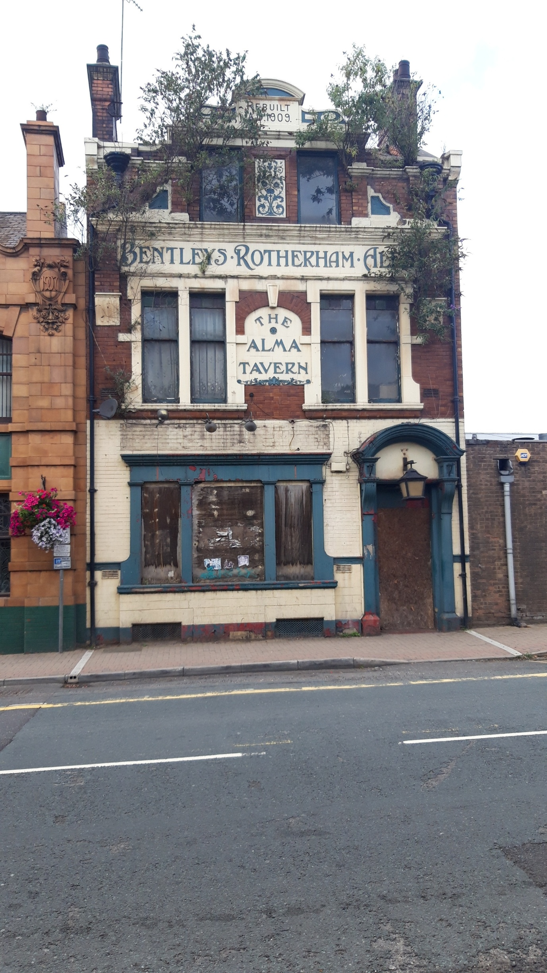

Rack and Ruin

Is our town – Rotherham - sustainable?

There continues to be a great deal of discussion locally about the state of our town centre, and it seems this discussion is widespread across many towns too.

People ask what has happened and why? Everyone seems to have an opinion and view of who is to blame.

We have tried to bring a few ideas together to look at the problem, why it has come about and why it will continue, unless there is radical political change

As always the causes of change in people’s lives and places is economic, and driving that economic change is always political ideas.

Older citizens of Rotherham will remember when the centre had really good and busy shops, such as Marks and Spencer, C&A, British Home Stores as well as gems like Charlie Denhams and the high quality grocers, Horace Brookes.

What happened?
The destruction of our local social economy happened.
The Tory government from 1979 set about destroying the large industrial trades unions that protected the jobs, terms and conditions of the two largest employment sectors: Coal and Steel. In order to do this they had virtually to destroy coal mining and steel production. By the late 1980s the work was gone, the suppliers of goods and services to these giant businesses were gone, the spending power in the town and roundabout was dramatically reduced. Between 1985 and 1990 the area lost 23,000 proper, well paid working class jobs. This resulted in shocks to the town centre, the local communities and businesses that are evident today.

Brutal intervention then leave to ‘market forces’
There were no real plans to soften the blows. People will remember the Enterprise Zones where businesses were offered rate relief if the set up there. Many existing town centre entities such as M and S relocated, leaving their previous business premises behind and empty. The jobs that came were in telesales, hairdressing and snack bars, none of which would support a house and family.

Since then we have grown accustomed to he problems of structural unemployment – bringing with it a flourishing drugs and associated crime scene.

Long-term effects of free market political policies
Other political factors have had an impact on the town: the efforts to ‘shrink the state’, cut public expenditure, reduce taxation on corporations and the rich, reduce local authority budgets and powers have all compacted the problems. The NHS is a smaller employer than it was, as is the local authority. The latter is given insufficient money by the government to run its essential services. The result is a shower of blame in their direction. When the local authority is shrunk there are fewer jobs and less spending power locally. Political neutered, all the local Councils can do now is implement central government’s dirty work.

We are now realising that the net impact of this sort of process over the past 40 years is to increase poverty and take away hope in areas like ours.

Over this period the main political party in power (the Tories) have remorselessly implemented a policy of taking money from the State. It was called monetarism, then Thatcherism, now austerity. They are all the same and the effect is the same.

Other policies have fed into this process: the attack on trades unions, reducing their powers by law, and in the case of the miners taking their members’ funds off them (remember sequestration) has resulted in an employment culture of casual, low-paid jobs, and massive profits for the employers.
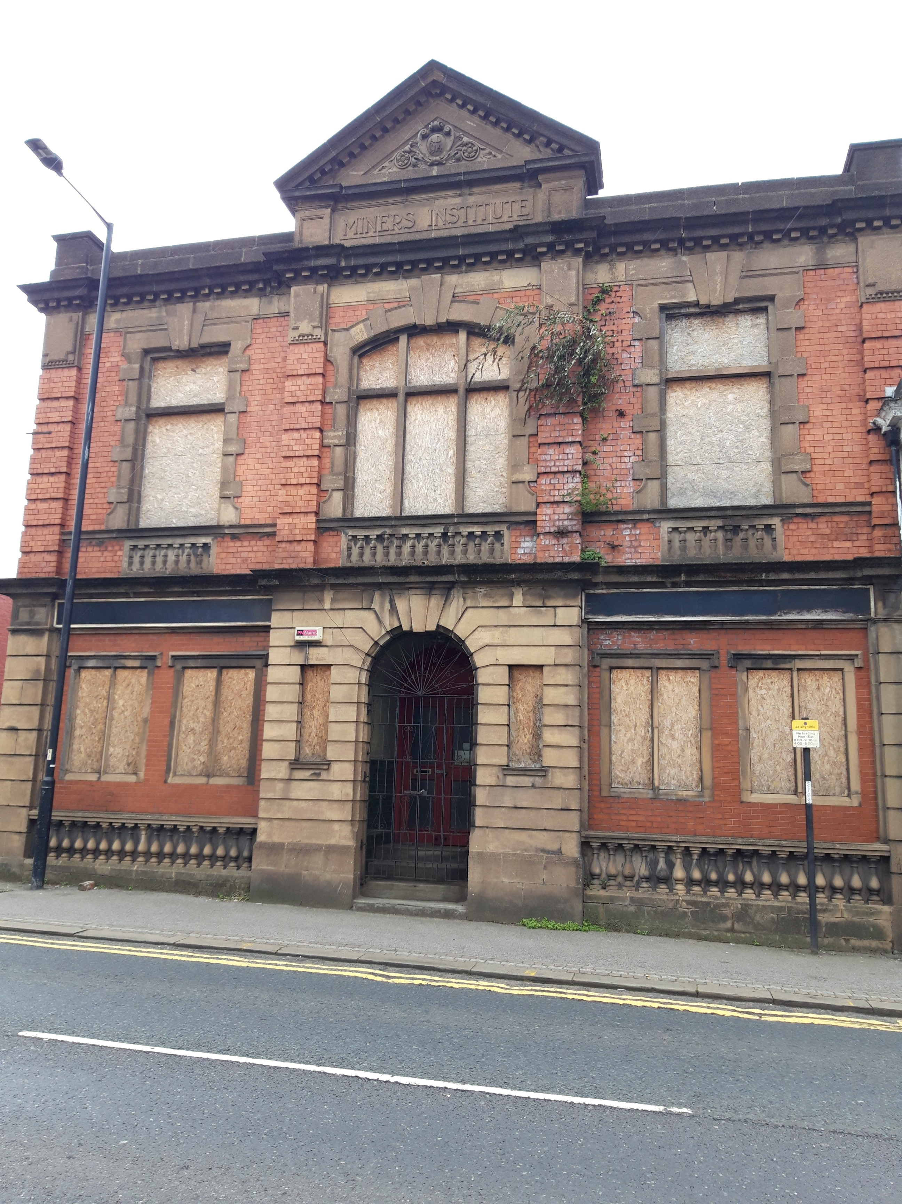
Privatisation
Let’s think about the effects of privatisation. The policy of selling off the state’s assets, activities and services built up through generations of taxation, has resulted in the following situation: we all still pay very much the same tax, but then have to buy former (state funded) services (transport, water, energy, child and age care as well, making us poorer.

Privatising public housing has resulted in an acute shortage of social housing and an expansion of private renting, which is unregulated. This takes more money out of the local economy, especially since many holdings are in rental companies (often located in London) designed to maximise rents for the owners
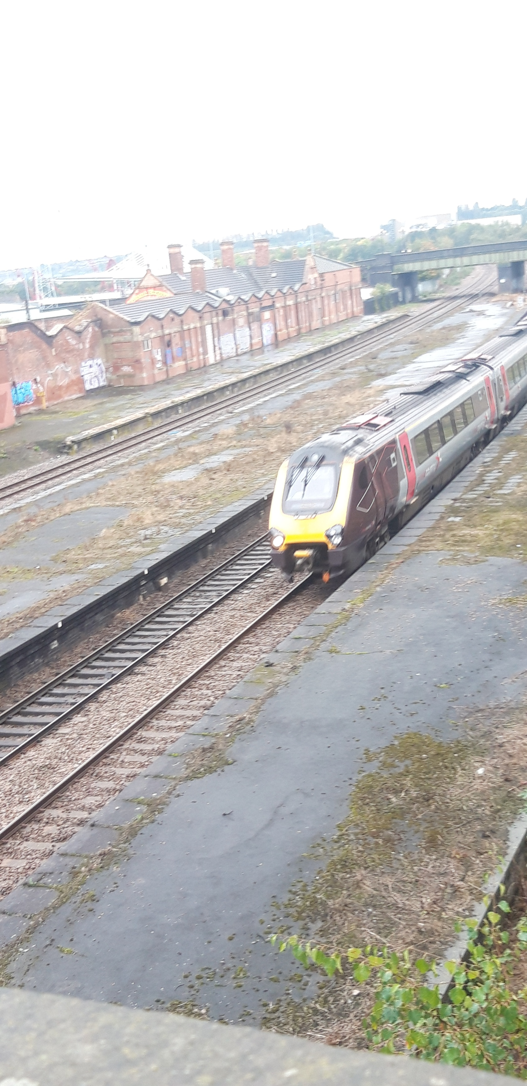
Other factors
So it’s now becoming clearer why our town centres are failing: there is simply insufficient local money to make them viable.

The rents for shop premises have followed the same rising levels of the other rental properties and it is simply the case that people cannot run successful business and pay these sorts of rents. In terms of local rates and council tax the local council’s hands are tied: they are legally obliged to reflect market values.

Car parking is a discretionary charge and for most councils it has become an essential income, but It does deter people from visiting the town centre.

Public transport is no longer cheap: using it takes more money out of the local pocket.

Out of town shopping malls clearly destroyed some local shops, but, bear in mind that the driving need of the time for local decision makers was to create jobs, this seemed like one way of doing so. In reality, it displaced jobs and the new shops were mainly national chains, not locally owned enterprises.

If we then add on to all those layers of destructive changes over time the phenomenon of on-line shopping, then we can see how serious the problems are for local town centres. Every time we buy something from Amazon we don’t purchase it locally, additionally it has to be delivered and that is not good environmentally.

Even worse, companies such as Amazon avoid their tax responsibilities, thus there’s even less money to send to areas like ours that are in desperate straights

Worst of all
We are poor: the wages figures for South Yorkshire tell us that
Sheffield City Region has the highest percentage of employees earning below the real Living Wage than any other region considered in the report. There are currently 145,000 earning below the real Living Wage, a total of 27% of all workers in the Sheffield City Region. (Living Wage Foundation, September 2018)
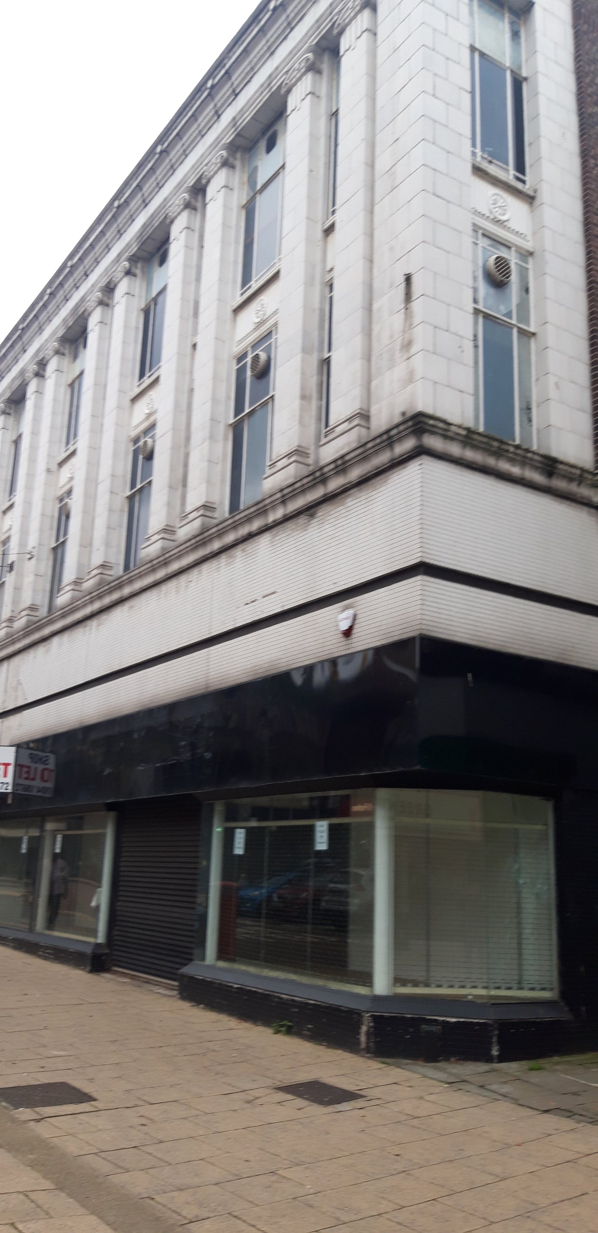
So that’s the problem: we are poorer, our incomes are lower, we have more personal debt, spend our scarce income away from the locality and then moan about

Looking ahead
Towns, as we have known them will have to change. There will be fewer shops and more living space. Specialist shops and shops of particular interest to collectors, cultural shoppers, start ups and boutiques will take over some of the vacant space.

Town spaces will need to be of good quality. Local authorities will need the power to punish landlords who let their properties decay and foul the environment. The ownership details of some abandoned business are unknown to the local authorities. Rent will need to be regulated and incentives for new ventures improved. The green environment will have to be improved ( to be fair, Rotherham has made some good improvements ), but it’s only a fraction of what is needed.

There needs to be a change of political ideology away from leaving everything to market forces, to making positive intervention. Local authorities need to have their economic powers restored and become once again engines of local development and growth as well as providers of inexpensive local services.

Keith Brookes (GMB Labour Affiliate) and Ted Hartley (local Labour Party member)
November 2019

